1. **<Store Owner> Manage New Request**

**Use Case Diagram**

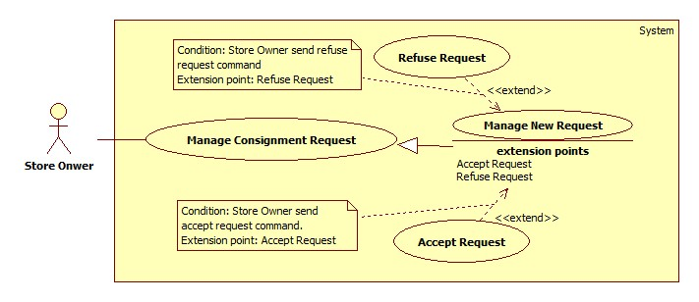

**Figure 3: <Store Owner> View Request List**

**Use Case Specification**

|  |  |  |  |
| --- | --- | --- | --- |
| **USE CASE – Manage New Request** | | | |
| **Use Case No.** | DHP6 | Use Case Version | 2.0 |
| **Use Case Name** | Manage New Request | | |
| **Author** | DucHC | | |
| **Date** | August 8, 2015 | Priority | High |
| **Actor**:   1. Store Owner.   **Summary**:   1. Show list of new request for current store.   **Goal**:   1. Store Owner view list of new request.   **Triggers**:   1. Store Owner send request the system to view new request list.   **Preconditions**:   1. Store Owner has logged onto the system.   **Post Conditions**:   1. **Success**: List of consignment request is shown. 2. **Fail**: Show error message.   **Main Success Scenario**:   |  |  |  | | --- | --- | --- | | Step | Actor Action | System Response | | 1 | Store owner send request the system to view new request list. | System shows new request list include following information:   1. “Tên sản phẩm”: label. 2. “Mã ký gửi”: label. 3. “Ngày gửi yêu cầu”: label. 4. “Ngày hẹn”: label. 5. “Giá mong muốn”: label.   System also shows on each row a “Xem” component for viewing details of that request. | | 2 | Store owner chooses a request to view details. | System shows details of that request with listed information:   1. “Ảnh”: image of product. 2. “Tên sản phẩm”: label. 3. “Loại”: label. 4. “Hãng”: label. 5. “Mô tả”: label. 6. “Độ mới”: label. 7. “Họ tên”: label. 8. “Điện thoại”: label. 9. “Email”: label. 10. “Địa chỉ”: label. 11. “Mã tài khoản”: label. 12. “Ngày ký gửi”: label. 13. “Ngày hẹn”: label. 14. “Cách giao hàng”: label. 15. “Ngày giao hàng”:     1. Default by the first date of “Ngày hẹn”.     2. Required. 16. “Giá tham khảo”: label. 17. “Giá mong muốn”: label.   System also shows some components below:   1. “Chấp nhận”: accept this request. 2. “Từ chối”: refuse this request. 3. “Đóng”: close details to go back to list new request.   [Exception: 1] |   **Alternative**: N/A  **Exceptions**:   |  |  |  | | --- | --- | --- | | No | Actor Action | System Response | | 1 | Store Owner sends command to view details when request has already handled. | System shows message: “Yêu cầu này đã được xử lý”. |   **Relationships**:   1. Included Use-case: N/A. 2. Extended Use-case: N/A. 3. Including Use-case: N/A. 4. Extending Use-case: Accept Request (Store Owner sends command to accept request), Refuse Request (Store Owner sends command to refuse request).   **Business Rules**:   1. Filter bar shall be shown to help Store Owner find consignment faster. 2. List are sorted by on request date in reverse chronological order. The most recent request appears first in the list, while the oldest one appears last. 3. This list shows new requests which haven’t been handled. 4. Store Owner will consider this request if store owner wants to accept it or not. | | | |

1. <Store Owner> Accept Request

**Use Case Diagram**



**Figure 3: <Store Owner> Accept Request**

**Use Case Specification**

|  |  |  |  |
| --- | --- | --- | --- |
| **USE CASE – Accept Request** | | | |
| **Use Case No.** | DHP7 | Use Case Version | 2.0 |
| **Use Case Name** | Accept Request | | |
| **Author** | DucHC | | |
| **Date** | August 8, 2015 | Priority | High |
| **Actor**:   1. Store Owner.   **Summary**:   1. Store Owner accepts a new request.   **Goal**:   1. Store Owner successfully accepts a request.   **Triggers**:   1. Store Owner send command to accept a request.   **Preconditions**:   1. Store Owner has logged onto the system. 2. Store Owner is viewing details of a new request.   **Post Conditions**:   1. **Success**: Successfully accept a request. 2. **Fail**: Show error message.   **Main Success Scenario**:   |  |  |  | | --- | --- | --- | | Step | Actor Action | System Response | | 1 | While viewing details of a new request, Store Owner sends command to accept a request. | System make that request accepted and inform Store Owner that the request has been accepted. |   **Alternative**: N/A  **Exceptions**:   |  |  |  | | --- | --- | --- | | No | Actor Action | System Response | | 1 | Store Owner sends command to accept a request when request has already handled. | System shows message: “Yêu cầu này đã được xử lý”. |   **Relationships**:   1. Included Use-case: N/A. 2. Extended Use-case: Manage New Request. 3. Including Use-case: N/A. 4. Extending Use-case: N/A   **Business Rules**:   1. After accepting request, this request’s status will change to “Đã chấp nhận yêu cầu”. 2. If accepted request has the value of “Cách giao hàng” is “Cửa hang đến nhận” and “Ngày giao hàng” is current day, system will inform Store Owner in mobile application about this request immediately. 3. After accepted request, Store Owner can update it later in managing accepted request. | | | |

1. <Store Owner> Refuse Request

**Use Case Diagram**



**Figure 3: <Store Owner> Refuse Request**

**Use Case Specification**

|  |  |  |  |
| --- | --- | --- | --- |
| **USE CASE – Refuse Request** | | | |
| **Use Case No.** | DHP8 | Use Case Version | 2.0 |
| **Use Case Name** | Refuse Request | | |
| **Author** | DucHC | | |
| **Date** | August 8, 2015 | Priority | High |
| **Actor**:   1. Store Owner.   **Summary**:   1. Store Owner refuse a new request.   **Goal**:   1. Store Owner successfully refuse a request.   **Triggers**:   1. Store Owner send command to refuse a request.   **Preconditions**:   1. Store Owner has logged onto the system. 2. Store Owner is viewing details of a new request.   **Post Conditions**:   1. **Success**: Successfully refuse a request. 2. **Fail**: Show error message.   **Main Success Scenario**:   |  |  |  | | --- | --- | --- | | Step | Actor Action | System Response | | 1 | While viewing details of a new request, Store Owner sends command to refuse a request. | System ask Store Owners to inform the reason. | | 2 | Store Owners provides a reason and send it to system. | System saves this reason and make this request refused.  [Exception 1] |   **Alternative**: N/A  **Exceptions**:   |  |  |  | | --- | --- | --- | | No | Actor Action | System Response | | 1 | Store Owner sends command to refuse a without providing a reason | System ask Store Owners to providing a reason. |   **Relationships**:   1. Included Use-case: N/A. 2. Extended Use-case: Manage New Request. 3. Including Use-case: N/A. 4. Extending Use-case: N/A   **Business Rules**:   1. After refusing request, this request’s status will change to “Đã từ chối”. 2. User can check this request in viewing refused request. | | | |

1. <Store Owner> Manage Accepted Request

**Use Case Diagram**

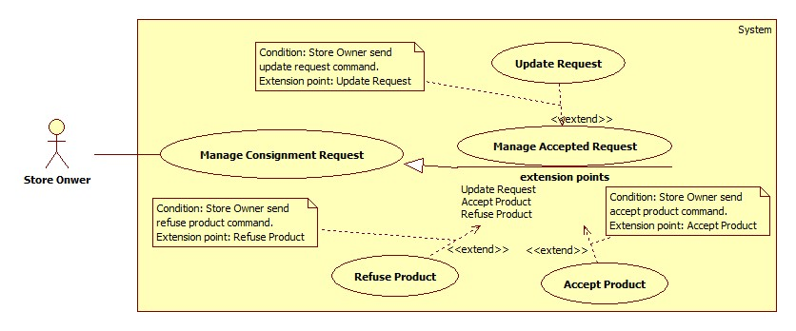

**Figure 3: <Store Owner> View Request List**

**Use Case Specification**

|  |  |  |  |
| --- | --- | --- | --- |
| **USE CASE – Manage Accepted Request** | | | |
| **Use Case No.** | DHP9 | Use Case Version | 2.0 |
| **Use Case Name** | Manage Accepted Request | | |
| **Author** | DucHC | | |
| **Date** | August 8, 2015 | Priority | High |
| **Actor**:   1. Store Owner.   **Summary**:   1. Show list of accepted request for current store.   **Goal**:   1. Store Owner view list of accepted request.   **Triggers**:   1. Store Owner send request the system to view accepted request list.   **Preconditions**:   1. Store Owner has logged onto the system.   **Post Conditions**:   1. **Success**: List of consignment request is shown. 2. **Fail**: Show error message.   **Main Success Scenario**:   |  |  |  | | --- | --- | --- | | Step | Actor Action | System Response | | 1 | Store owner send request the system to view new request list. | System shows accepted request list include following information:   1. “Tên sản phẩm”: label. 2. “Mã ký gửi”: label. 3. “Ngày nhận yêu cầu”: label. 4. “Ngày hẹn”: label. 5. “Giá mong muốn”: label. 6. “Cách giao hàng”: label   System also shows on each row a “Xem” component for viewing details of that request. | | 2 | Store owner chooses a request to view details. | System shows details of that request with listed information:   1. “Ảnh”: image of product. 2. “Tên sản phẩm”:    1. Free text input    2. Length: 5 – 100.    3. Required. 3. “Loại”: Choose from a list (“Giày nam”, “Áo khác nam”, “Túi xách nữ”, “Giày dép nữ”…). 4. “Hãng”:    1. Free text input.    2. Length: 0-100. 5. “Mô tả”: Free text input. 6. “Độ mới”:    1. Free text input.    2. Format: Number 1- 99.    3. Required. 7. “Họ tên”:    1. Free text input.    2. Format: Number 1- 99.    3. Required. 8. “Điện thoại”:    1. Free text input    2. Format: number.    3. Length: 9-11.    4. Required. 9. “Email”: Free text input. 10. “Địa chỉ”: Free text input. 11. “Cách thanh toán”:     1. Store Owner chooses from 2 option: “Tiền mặt” or “Tài khoản paypal”.     2. Default chosen by who send this request. 12. “Mã tài khoản”: Free text input. 13. “Ngày ký gửi”: label. 14. “Ngày hẹn”: label. 15. “Cách giao hàng”:     1. Store Owner chooses from 2 option: “Cửa hang đến nhận” or “Tự mang đến”.     2. Default chosen by who send this request. 16. “Ngày giao hàng”:     1. Default by the first date of “Ngày hẹn”.     2. Required. 17. “Giá tham khảo”: label. 18. “Giá mong muốn”: label. 19. “Giá thỏa thuận”:     1. Free text input.     2. Format: Number.     3. Required.   System also shows some components below:   1. “Cập nhật”: update this request 2. “Chấp nhận”: accept product. 3. “Từ chối”: refuse product. 4. “Đóng”: close details to go back to list accepted request.   [Exception: 1] |   **Alternative**: N/A  **Exceptions**:   |  |  |  | | --- | --- | --- | | No | Actor Action | System Response | | 1 | Store Owner sends command to view details when request has already handled. | System shows message: “Yêu cầu này đã được xử lý”. |   **Relationships**:   1. Included Use-case: N/A. 2. Extended Use-case: N/A. 3. Including Use-case: N/A. 4. Extending Use-case: Update Request, (Store Owner sends command to update request), Accept Product (Store Owner sends command to accept product), Refuse Product (Store Owner sends command to refuse product).   **Business Rules**:   1. Filter bar shall be shown to help Store Owner find consignment faster. 2. List are sorted by on request date in reverse chronological order. The most recent request appears first in the list, while the oldest one appears last. 3. This list shows accepted requests which haven’t been handled. 4. In website application, Store Owner can view all the accepted request including if store has to come to customer house to take product or customers bring product to store. 5. In mobile application, store owner can only view which those store owner has to come to take product. Store owner will receive on each day a list of products have to be taken in current day and the next day. | | | |

1. **<Store Owner> Update Request**

**Use Case Diagram**



**Figure 3: <Store Owner> Update Request**

**Use Case Specification**

|  |  |  |  |
| --- | --- | --- | --- |
| **USE CASE – Update Request** | | | |
| **Use Case No.** | DHP10 | Use Case Version | 2.0 |
| **Use Case Name** | Update Request | | |
| **Author** | DucHC | | |
| **Date** | August 8, 2015 | Priority | High |
| **Actor**:   1. Store Owner.   **Summary**:   1. Store Owner update an accepted request.   **Goal**:   1. Store Owner successfully update an accepted request.   **Triggers**:   1. Store Owner send command to update request.   **Preconditions**:   1. Store Owner has logged onto the system. 2. Store Owner is viewing details of an accepted request.   **Post Conditions**:   1. **Success**: Successfully update accepted request. 2. **Fail**: Show error message.   **Main Success Scenario**:   |  |  |  | | --- | --- | --- | | Step | Actor Action | System Response | | 1 | While viewing details of an accepted request, Store Owner sends command to update it. | System update this request with provided information.  [Exception 1,2] |   **Alternative**: N/A  **Exceptions**:   |  |  |  | | --- | --- | --- | | No | Actor Action | System Response | | 1 | Store Owner does not provide valid information. | System show a message: “Xin nhập đúng thông tin”. | | 2 | Store Owner sends command to update when this request is already handled. | System show a message: “Yêu cầu này đã được xử lý”. |   **Relationships**:   1. Included Use-case: N/A. 2. Extended Use-case: Manage Accepted Request. 3. Including Use-case: N/A. 4. Extending Use-case: N/A   **Business Rules**:   1. After updating request, this request information will be changed. 2. If Store Owner updates “Ngày giao hàng” to “current Date and “Cách giao hàng” to “Cửa hàng đến nhận”, system will inform Store Owner in mobile application about this request. | | | |

1. **<Store Owner> Accept Product**

**Use Case Diagram**



**Figure 3: <Store Owner> Accept Product**

**Use Case Specification**

|  |  |  |  |
| --- | --- | --- | --- |
| **USE CASE – Accept Product** | | | |
| **Use Case No.** | DHP11 | Use Case Version | 2.0 |
| **Use Case Name** | Accept Product | | |
| **Author** | DucHC | | |
| **Date** | August 8, 2015 | Priority | High |
| **Actor**:   1. Store Owner.   **Summary**:   1. Store Owner accept product.   **Goal**:   1. Store Owner successfully accept product.   **Triggers**:   1. Store Owner send command to accept product.   **Preconditions**:   1. Store Owner has logged onto the system. 2. Store Owner is viewing details of an accepted request.   **Post Conditions**:   1. **Success**: Successfully accept product. 2. **Fail**: Show error message.   **Main Success Scenario**:   |  |  |  | | --- | --- | --- | | Step | Actor Action | System Response | | 1 | While viewing details of an accepted request, Store Owner sends command to accept product. | System saves provided information and changes this request to “Đã nhận hàng”.  [Exception 1, 2] |   **Alternative**: N/A  **Exceptions**:   |  |  |  | | --- | --- | --- | | No | Actor Action | System Response | | 1 | Store Owner does not provide valid information. | System shows message: “Xin nhập đúng thông tin”. | | 2 | Store Owner sends command to accept product when this request is already handled. | System shows message: “Yêu cầu này đã được xử lý”. |   **Relationships**:   1. Included Use-case: N/A. 2. Extended Use-case: Manage New Request. 3. Including Use-case: N/A. 4. Extending Use-case: N/A   **Business Rules**:   1. After accepting product, Store Owner will store the product and set the day to go on web for shopping. 2. Mobile application have the same function as this, to accept an product and bring it back to store. | | | |

1. **<Store Owner> Refuse Product**

**Use Case Diagram**



**Figure 3: <Store Owner> Refuse Request**

**Use Case Specification**

|  |  |  |  |
| --- | --- | --- | --- |
| **USE CASE – Refuse Product** | | | |
| **Use Case No.** | DHP6 | Use Case Version | 2.0 |
| **Use Case Name** | Refuse Product | | |
| **Author** | DucHC | | |
| **Date** | August 8, 2015 | Priority | High |
| **Actor**:   1. Store Owner.   **Summary**:   1. Store Owner refuse a product.   **Goal**:   1. Store Owner successfully refuse a product.   **Triggers**:   1. Store Owner send command to refuse a product.   **Preconditions**:   1. Store Owner has logged onto the system. 2. Store Owner is viewing details of an accepted request.   **Post Conditions**:   1. **Success**: Successfully refuse a product. 2. **Fail**: Show error message.   **Main Success Scenario**:   |  |  |  | | --- | --- | --- | | Step | Actor Action | System Response | | 1 | While viewing details of a new request, Store Owner sends command to refuse a product. | System ask Store Owners to inform the reason. | | 2 | Store Owners provides a reason and send it to system. | System saves this reason and make this request refused.  [Exception 1] |   **Alternative**: N/A  **Exceptions**:   |  |  |  | | --- | --- | --- | | No | Actor Action | System Response | | 1 | Store Owner sends command to refuse a without providing a reason | System ask Store Owners to providing a reason. |   **Relationships**:   1. Included Use-case: N/A. 2. Extended Use-case: Manage New Request. 3. Including Use-case: N/A. 4. Extending Use-case: N/A   **Business Rules**:   1. After refusing request, this request’s status will change to “Đã từ chối”. 2. User can check this request in viewing refused request. | | | |

1. **<Store Owner> View Refused Request**

**Use Case Diagram**

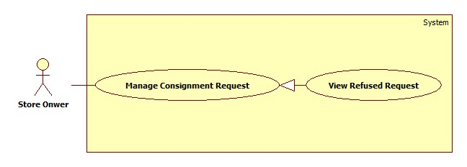

**Figure 3: <Store Owner> View Refused Request**

**Use Case Specification**

|  |  |  |  |
| --- | --- | --- | --- |
| **USE CASE – View Refused Request** | | | |
| **Use Case No.** | DHP6 | Use Case Version | 2.0 |
| **Use Case Name** | View Refused Request | | |
| **Author** | DucHC | | |
| **Date** | August 8, 2015 | Priority | High |
| **Actor**:   1. Store Owner.   **Summary**:   1. Show list of refused request for current store.   **Goal**:   1. Store Owner view list of refused request.   **Triggers**:   1. Store Owner send request the system to view refused request list.   **Preconditions**:   1. Store Owner has logged onto the system.   **Post Conditions**:   1. **Success**: List of consignment request is shown. 2. **Fail**: Show error message.   **Main Success Scenario**:   |  |  |  | | --- | --- | --- | | Step | Actor Action | System Response | | 1 | Store owner send request the system to view new request list. | System shows new request list include following information:   1. “Tên sản phẩm”: label. 2. “Mã ký gửi”: label. 3. “Ngày gửi yêu cầu”: label. 4. “Ngày từ chối”: label.   System also shows on each row a “Xem” component for viewing details of that request. | | 2 | Store owner chooses a request to view details. | System shows details of that request with listed information:   1. “Ảnh”: image of product. 2. “Tên sản phẩm”: label. 3. “Mô tả”: label. 4. “Độ mới”: label. 5. “Họ tên”: label. 6. “Điện thoại”: label. 7. “Email”: label. 8. “Địa chỉ”: label. 9. “Ngày ký gửi”: label. 10. “Giá mong muốn”: label. 11. “Trạng thái”: label. 12. “Lí do”: label. |   **Alternative**: N/A  **Exceptions**: N/A  **Relationships**:   1. Included Use-case: N/A. 2. Extended Use-case: N/A. 3. Including Use-case: N/A. 4. Extending Use-case: N/A.   **Business Rules**:   1. Filter bar shall be shown to help Store Owner find consignment faster. 2. List are sorted by on request date in reverse chronological order. The most recent request appears first in the list, while the oldest one appears last. 3. This list shows refused requests. 4. Store Owner will review the request store refused and the reason why. | | | |

1. **<Store Owner> View Cancelled Request**

**Use Case Diagram**

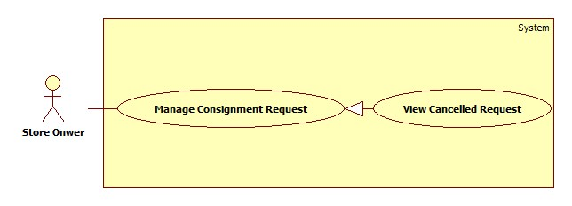

**Figure 3: <Store Owner> View Cancelled Request**

**Use Case Specification**

|  |  |  |  |
| --- | --- | --- | --- |
| **USE CASE – View Cancelled Request** | | | |
| **Use Case No.** | DHP6 | Use Case Version | 2.0 |
| **Use Case Name** | View Cancelled Request | | |
| **Author** | DucHC | | |
| **Date** | August 8, 2015 | Priority | High |
| **Actor**:   1. Store Owner.   **Summary**:   1. Show list of refused request for current store.   **Goal**:   1. Store Owner view list of refused request.   **Triggers**:   1. Store Owner send request the system to view refused request list.   **Preconditions**:   1. Store Owner has logged onto the system.   **Post Conditions**:   1. **Success**: List of consignment request is shown. 2. **Fail**: Show error message.   **Main Success Scenario**:   |  |  |  | | --- | --- | --- | | Step | Actor Action | System Response | | 1 | Store owner send request the system to view new request list. | System shows new request list include following information:   1. “Tên sản phẩm”: label. 2. “Mã ký gửi”: label. 3. “Ngày gửi yêu cầu”: label. 4. “Ngày từ chối”: label.   System also shows on each row a “Xem” component for viewing details of that request. | | 2 | Store owner chooses a request to view details. | System shows details of that request with listed information:   1. “Ảnh”: image of product. 2. “Tên sản phẩm”: label. 3. “Mô tả”: label. 4. “Độ mới”: label. 5. “Họ tên”: label. 6. “Điện thoại”: label. 7. “Email”: label. 8. “Địa chỉ”: label. 9. “Ngày ký gửi”: label. 10. “Giá mong muốn”: label. 11. “Trạng thái”: label. |   **Alternative**: N/A  **Exceptions**: N/A  **Relationships**:   1. Included Use-case: N/A. 2. Extended Use-case: N/A. 3. Including Use-case: N/A. 4. Extending Use-case: N/A.   **Business Rules**:   1. Filter bar shall be shown to help Store Owner find consignment faster. 2. List are sorted by on request date in reverse chronological order. The most recent request appears first in the list, while the oldest one appears last. 3. This list shows refused requests. 4. Store Owner will review the request store refused and the reason why. | | | |